**User Manual Document**

This document includes the screenshots of all the working components in the app.

1. **Login Screen**

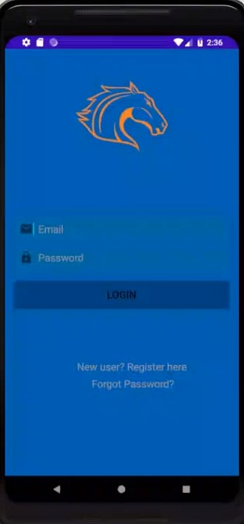

1. **Registration**

1. **Home Screen**

1. **Dine In**

1. **UTA Health**

1. **SEVA**

1. **UTA FIT**

1. **UTA PAY**



